**CSCE 5214 SOFTWARE ENGINEERING FOR ARTIFICIAL INTELLIGENCE**

**Project link**: <https://github.com/PartheshSoni/emotion-based-music-player>

**Group Number**: 15

**Group Members**:

* Grishma Tandu (11616220)
* Snehasri Doma (11605246)
* Aparna Sunkara(11604093)
* Soniya Tirumalasetty(11702585)
* Kavya sree Chandhi (11702484)

**Project Title**: Developing a Music player system based on Emotion based on IEEE standards.

**Abstract:** The Emotion-Based Music Player project aims to improve user experience by integrating emotion recognition technology. It uses facial recognition, biometric sensors, and machine learning algorithms to analyze users' emotions in real-time. The player features a diverse music database with emotional attributes, enabling dynamic playlist generation. It also focuses on user personalization, allowing profiles and personalized music recommendations. The project combines React Native, Node.js, MongoDB, and OpenCV for cross-platform compatibility and database management.

**Objectives:**

The Emotion-Based Music Player project aims to achieve the following objectives, which include:

1.**Recognizing Emotions**: To reliably determine users' emotional states, integrate powerful emotion detection technology that makes use of biometric sensors, machine learning algorithms, and facial recognition.

2. **Database for Music**: Build a vast and varied music library with a variety of styles and songs, all appropriately labeled with emotions like joy, sorrow, euphoria, and relaxation.

3. **Customization by the User**: Permit users to fill out profiles with their own tastes so that the system can learn from their actions over time and make more individualized and accurate music recommendations.

4.**Instantaneous Analysis**: While listening to music, keep an eye on users' emotional states and instantly modify the playlist to suit their current state of mind.

5.**Adaptable Playlists**: Using emotions that have been recognized, create dynamic playlists that will play music in a way that keeps the user's listening experience smooth and emotionally consistent.

6.**Mechanism for User Feedback**: Give consumers the ability to manually enter their emotional states so that the algorithm can adjust and become more accurate at identifying emotions.

7.**Combining Wearable Technology**: Link to well-known wearables, such smartwatches and fitness trackers, to collect more biometric information for more accurate emotion identification.

8.**Cross-Platform Harmoniousness**: Provide cross-platform compatibility for the music player so that consumers can use it on a variety of iOS and Android-powered devices.

9, **Privacy and Security**: Establish strong security protocols to safeguard user biometric information and guarantee adherence to data privacy laws, fostering user confidence.

10. **Market Analysis**: To comprehend current emotion-based music applications, spot loopholes, and add features that make the Emotion-Based Music Player unique in terms of functionality and user experience, conduct in-depth market research.

11.**User Involvement:** After deployment, keep an eye on user engagement metrics and make ongoing adjustments based on feedback from users to maintain good usability and satisfaction.

12.**Transform Music-Interaction**: By developing a fresh and deeply moving listening experience, you may redefine the relationship between users and music and establish a new benchmark for music player applications.

**Scope**:

The goal of the emotion-based music player project is to combine technology and emotions to transform the way people listen to music. It takes voice, text, or facial expression data as input to determine and react to the user's emotions using artificial intelligence (AI). Through data analysis, the system learns about the user over time and recommends emotionally appropriate music from its vast catalog. This technology combines technology with human nature.

**External Entities**: User, Web Cam – major input, Music player

**Responsibilities**: User interface and input, music recommendation, and emotion recognition

**Major Output:** The system creates personalized music playlists based on user emotions and preferences, allowing users to add or remove songs, and uses user logins for future development.

**Techniques**:

The project will be carried out using a phased approach, comprising the following phases:

1. **Research and Planning**: The project’s scope, feasibility study and scope are discussed during this phase.
2. **Design and Architecture**: To find the system architecture, database design and user interface design.
3. **Development**: Develop backend infrastructure using Node.js and Express, APIs for user profiles, music database access, and emotion recognition, cross-platform frontend using React Native, and emotion recognition module.
4. **Testing**: In this stage, the software project will be subjected to different kinds of testing to find potential attack points and gauge its resistance to online attacks
5. **Deployment**: The Emotion-Based Music Player will be deployed on various platforms, monitored for user engagement, system performance, and emotion recognition accuracy, and optimized based on real-world usage patterns.
6. **Post Deployment and Continuous Improvement**: Phase 6 involves post-deployment and continuous improvement, focusing on user feedback, feature enhancements, and staying updated with emerging technologies and user demands.

**Architecture of Emotion based Music System**

**Responsibilities:**

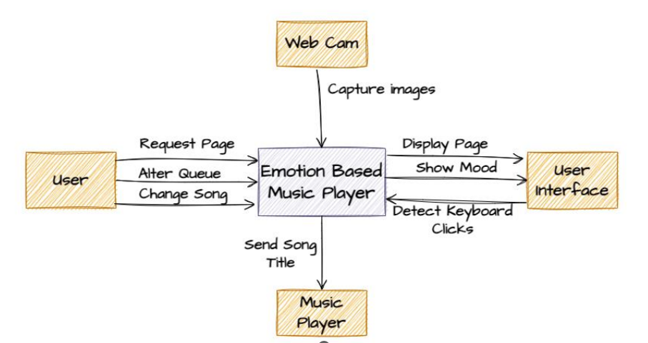

**Fig:** Context diagram of Emotion based Music system

**Functionalities**:

The playlist is dynamically changed by the emotion-based music system to reflect the user's mood and emotional condition, giving them a personalized music experience. Users are free to switch tracks at any time while maintaining their preferred musical tastes. Using webcam photos and sophisticated facial recognition and body language analysis, the system detects mood accurately and generates playlists that correspond with the user's emotions. With just a single command, users can easily pause or resume music, allowing their listening experience to adapt to their shifting moods.

Here is the picture that depicts UML case diagram.

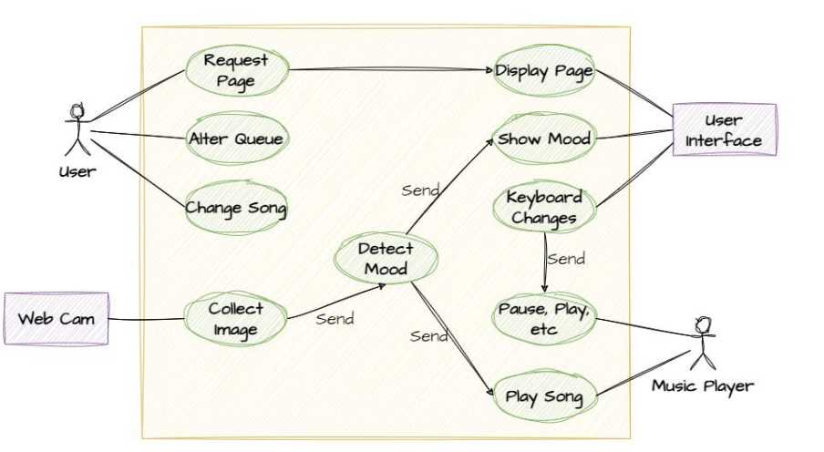

Here is the picture that depicts UML Component diagram

**Deliverables**:

1. The project's technique and plan should be documented.
2. An assessment report that summarizes the results of the project's investigation, examination, and testing.
3. suggestions for improving the security of the software project.
4. An executive summary that compiles the overview of the project, recommendations and findings.

**Challenges**:

This phase involves multiple diagrams, therefore visualizing and documenting

1. It was difficult to use diverse approaches for the same problem.

2. Everything on the website was either in code or was meant to be extracted and offered in a diagrammatic fashion.

**Conclusion**:

The Emotion-Based Music Player project is a groundbreaking initiative that uses advanced technologies like facial recognition, biometric sensors, and machine learning algorithms to create a personalized music listening experience. The project's success is attributed to a systematic approach that includes thorough research, planning, design, development, testing, and deployment. The project's dynamic playlist generation based on users' emotions is significant, and its deliverables, such as market research reports and testing documentation, serve as references for future development. The project aims to create a deep emotional connection between users and their music, setting a new standard in music player technology.